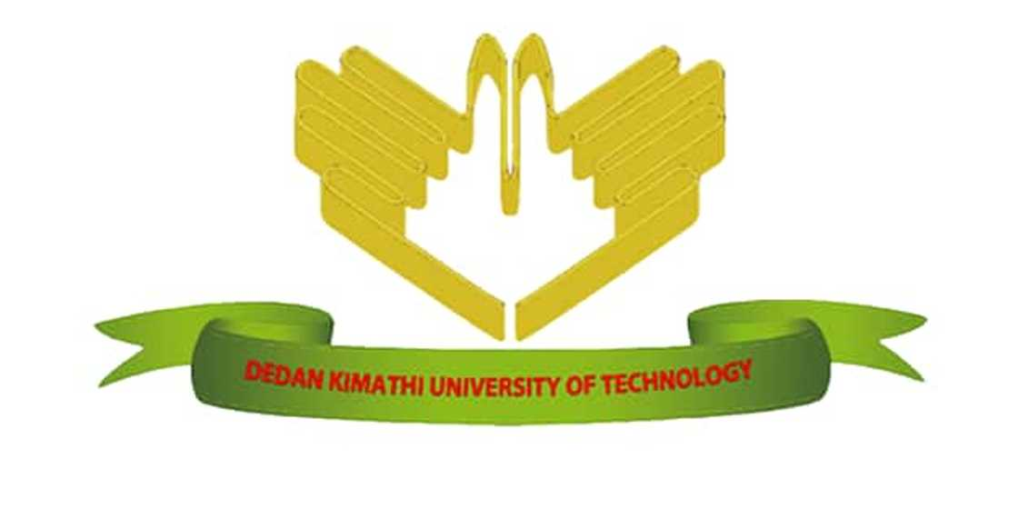
DEDAN KIMATHI UNIVERSITY OF TECHNOLOGY
SCHOOL OF COMPUTER SCIENCE AND INFORMATION TECHNOLOGY
BY
NAME: JAMES WAHITI
REGISTRATION NUMBER: C025-01-0832/2022
SUPERVISOR: DR. PATRICK GIKUNDA
CAPSTONE PROJECT: AFRICAN CULTURE AND GENDER AWARENESS
PROJECT TITLE
THE ROLE OF INFORMATION TECHNOLOGY IN PRESERVING AFRICAN CULTURE AND PROMOTING GENDER INCLUSION
An abstract submitted in partial fulfillment of the requirements for the award of the degree of Bachelor of Science in Information Technology of Dedan Kimathi University of Technology

January 2026

Abstract
This presentation examines the role of information technology in preserving African culture while promoting gender awareness and inclusion within contemporary society. African culture encompasses language, traditions, values, and indigenous knowledge systems that have historically been transmitted through oral and communal practices. However, globalization and rapid technological advancement have contributed to the erosion of cultural heritage and the marginalization of certain social groups, particularly women.
Information technology provides effective tools for documenting, preserving, and disseminating African cultural heritage through digital archives, multimedia platforms, and online knowledge repositories. Technologies such as databases, mobile applications, and artificial intelligence systems enable the storage and sharing of cultural information in accessible and sustainable formats. These digital solutions ensure that cultural knowledge is preserved for future generations while remaining relevant in modern educational and social contexts.
Gender awareness remains a critical issue in African societies, where women have traditionally faced limited access to education, technology, and economic opportunities. The digital divide has further intensified gender inequalities, particularly in access to information and communication technologies. By leveraging information technology, opportunities for inclusive education, digital skills development, and economic participation can be expanded for women and girls.
The presentation highlights how information technology can serve as a catalyst for cultural preservation and gender inclusion, demonstrating its potential to support social equity, empower marginalized groups, and promote sustainable development within African communities.

Muhtasari
Uwasilishaji huu unachunguza jukumu la teknolojia ya habari katika kuhifadhi utamaduni wa Afrika na kukuza uelewa wa kijinsia pamoja na ushirikishwaji wa kijinsia katika jamii ya kisasa. Utamaduni wa Afrika unajumuisha lugha, mila, desturi, maadili, na mifumo ya maarifa ya asili ambayo kwa muda mrefu imekuwa ikipitishwa kupitia mawasiliano ya mdomo na maisha ya kijamii. Hata hivyo, athari za utandawazi na maendeleo ya haraka ya teknolojia zimesababisha kupungua kwa urithisho wa kitamaduni na kuendelea kuwepo kwa ukosefu wa usawa wa kijinsia, hususan kwa wanawake.
Teknolojia ya habari hutoa nyenzo muhimu za kuhifadhi, kurekodi, na kusambaza urithi wa kitamaduni wa Afrika kupitia kumbukumbu za kidijitali, majukwaa ya vyombo vya habari, na hifadhidata za mtandaoni. Matumizi ya teknolojia kama hifadhidata, programu za simu, na mifumo ya akili bandia huruhusu uhifadhi wa taarifa za kitamaduni kwa njia endelevu na inayofikika kwa urahisi. Mbinu hizi huhakikisha kuwa maarifa ya kitamaduni yanahifadhiwa kwa vizazi vijavyo huku yakiendelea kuwa na umuhimu katika muktadha wa kisasa.
Uelewa wa kijinsia bado ni changamoto kubwa katika jamii nyingi za Afrika, ambapo wanawake kwa muda mrefu wamekumbwa na upungufu wa fursa katika elimu, teknolojia, na shughuli za kiuchumi. Mgawanyiko wa kidijitali umeongeza zaidi tofauti hizi, hasa katika upatikanaji wa teknolojia ya habari na mawasiliano. Kupitia matumizi sahihi ya teknolojia ya habari, fursa za elimu jumuishi, maendeleo ya ujuzi wa kidijitali, na ushiriki wa kiuchumi kwa wanawake na wasichana zinaweza kupanuliwa.
Kwa ujumla, uwasilishaji huu unaonesha jinsi teknolojia ya habari inaweza kutumika kama kichocheo cha kuhifadhi utamaduni wa Afrika na kukuza usawa wa kijinsia, hivyo kuchangia maendeleo endelevu, uwezeshaji wa makundi yaliyotengwa, na haki ya kijamii katika jamii za Afrika.

Muthabari
Uwasilishaji uyu urĩa gũcookereria ũrĩa tekinolojia ya habari yahotithagia gũthikĩra na gũtũũra ũtamaduni wa Afrika hamwe na gũcookereria ũmenyithia wa kijinsia na ũkũrũkĩrĩria wa arĩa a kĩrĩa kĩa andũ. Ũtamaduni wa Afrika ũgũtirĩte lugha, mĩtugo na mĩhĩrĩga, mĩtugo ya maadili, na mĩhũndũrĩria ya ũmenyithia wa kĩrĩra iria igũcookereriagwo kwa ihinda rĩingĩ na mũromo na wĩra wa kũrũgana. No ningĩ, gũcookereria kwa gĩthaka kwa utandawazi na maendeleo ma kinene ma tekinolojia kũrehithagia gũthikũka kwa ũtamaduni na kũrutithia mathĩna ma ũkũrũkĩrĩria wa kijinsia, mũno mũno kwa atumia.
Tekinolojia ya habari nĩ ya gũheana ndũmũrũ cia mũno cia gũtũũra, gũcooka, na gũcookereria ũtamaduni wa Afrika kuuma kũmenyithia kwa ndũmũrũ, mĩtũrũrũ ya mahũthĩrĩro, na hũndũrĩria cia mtandao. Gũtũmĩtio wa tekinolojia ta hũndũrĩria cia ndũmũrũ, mapurogiramu ma thirikari cia mũtĩ, na mitĩrĩrũ ya akili bandia ũhotithagia gũtũũra ũmenyithia wa ũtamaduni kwa njira iria irĩa ya kũmenyithia na ya gũtũũra ihinda rĩa mũno. Njira ici ithikĩrĩria atĩ ũmenyithia wa ũtamaduni ũtũũrĩte ũtiga wa andũ arĩa magũkũũra kũrĩa ũgĩcooka mũno na ihinda rĩa mũno.
Ũmenyithia wa kijinsia nĩ mathĩna mũnene mũno kũrĩa Afrika, handũ ha rũrĩmĩ rũingĩ atumia maamũgĩtĩkĩra rĩrĩa rĩa gũthoma, tekinolojia, na mĩtugo ya mĩno ya ũgĩrĩrĩ. Mgawanyiko wa kidijitali nĩ wũrĩte gũkũrũkĩra mathĩna macio, mũno mũno kũrĩa gũthikĩra tekinolojia ya habari na ya gũkũrũkĩra. Na gũtũmĩtio wa tekinolojia ya habari kwa njira ya mũno, atumia na airĩtu mahotithagio gũthikĩra ũthomi wa gũkũrũkĩrĩria, gũthoma uũgĩ wa kidijitali, na gũkũrũkĩra mĩtugo ya ũgĩrĩrĩ.
Mũno mũno, uwasilishaji uyu ũmenyithagia ũrĩa tekinolojia ya habari yahotithagia gũcookeria ũtamaduni wa Afrika na gũcookereria ũkũrũkĩrĩria wa kijinsia, ikũrĩa igũthikĩra maendeleo ma gũtũũra ihinda rĩa mũno, ũgũcokia wa arĩa me rũrĩmĩ rũnini, na watho wa andũ kũrĩa Afrika.

